“Encourage one another and build each other up”
1 Thessalonians 5:11

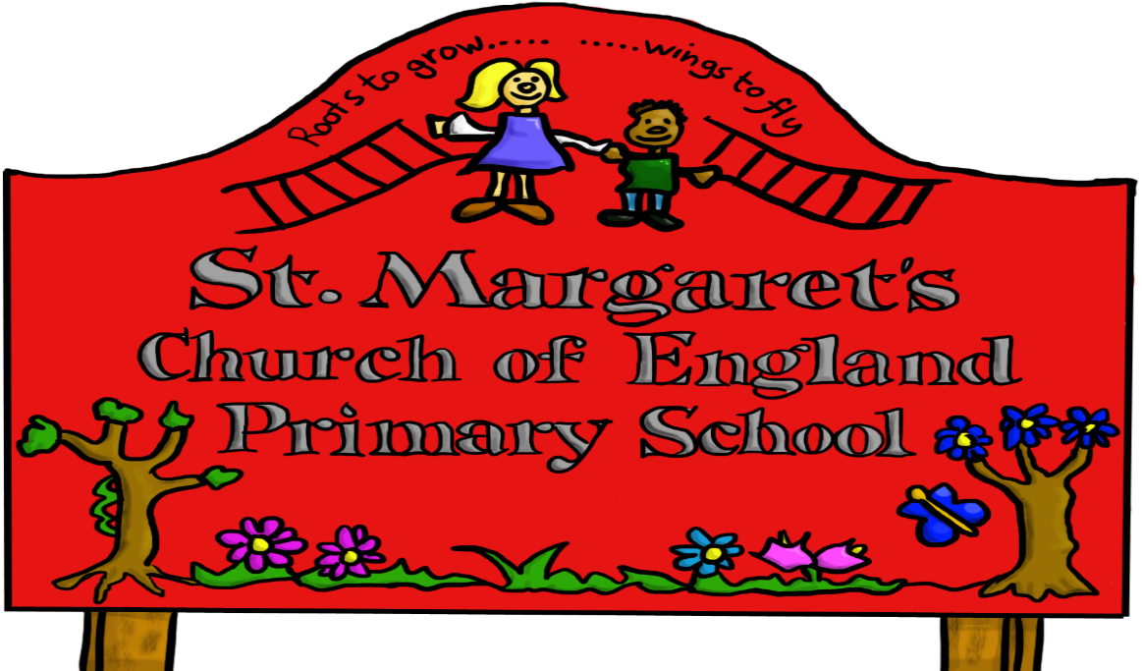

Reviewed Jan 2021

To find out more about online safety, please read our Online Safety Policy.
You can find support and online safety resources for parents at parentsafe.lgfl.net
Please discuss the following with your child:

My name is ____________________ Year Group
: childrenscommissioner.gov.uk/our-work/digital/5-a-day/
To stay SAFE online and on my devices, I follow the Digital 5 A Day and:
- I only USE devices or apps, sites or games if an adult I trust says I am allowed to
- I ASK for help if I’m stuck or not sure
- I TELL an adult I trust if I’m upset, worried, scared or confused
- If I get a FUNNY FEELING in my tummy, I talk to an adult
- I look out for my FRIENDS and tell someone if they need help
- I KNOW people online aren’t always who they say they are
- Anything I do online can be shared and might stay online FOREVER
- I don’t keep SECRETS or do DARES AND CHALLENGES just because someone tells me I have to
- I don’t change CLOTHES or get undressed in front of a camera
- I do not share my name, address or school name when I am online
- I am KIND and polite to everyone
My adults I trust are:
____________________ at school
____________________ at home

